Service Only Coach Registration

How to register on the Vault – New Member

Go to the England Boxing Vault https://www.englandboxinginsight.com/auth/login

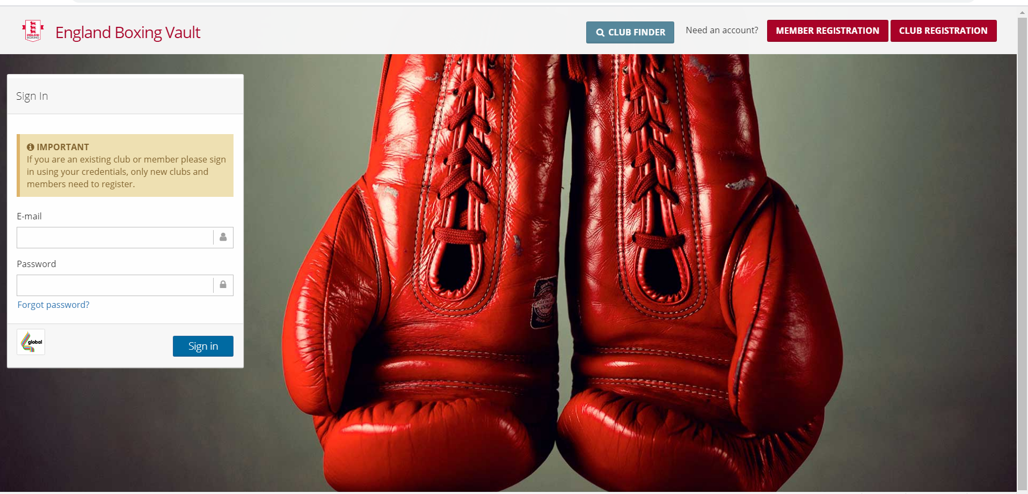

Click on the member registration tab in the top right hand corner

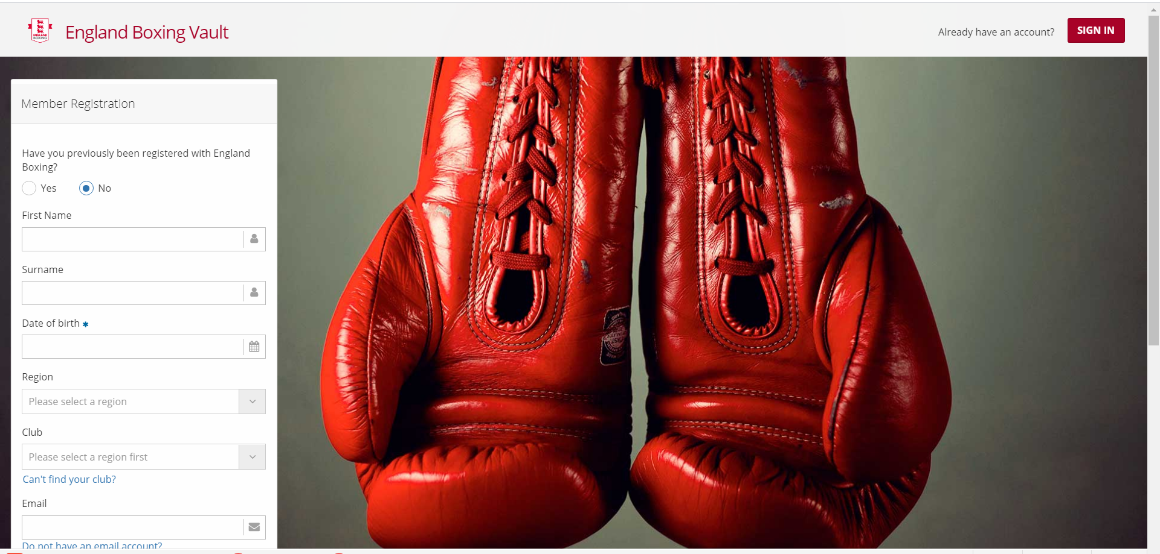

Enter all your details as prompted on screen

Your region is UKAFBA
Your Club is Army BA

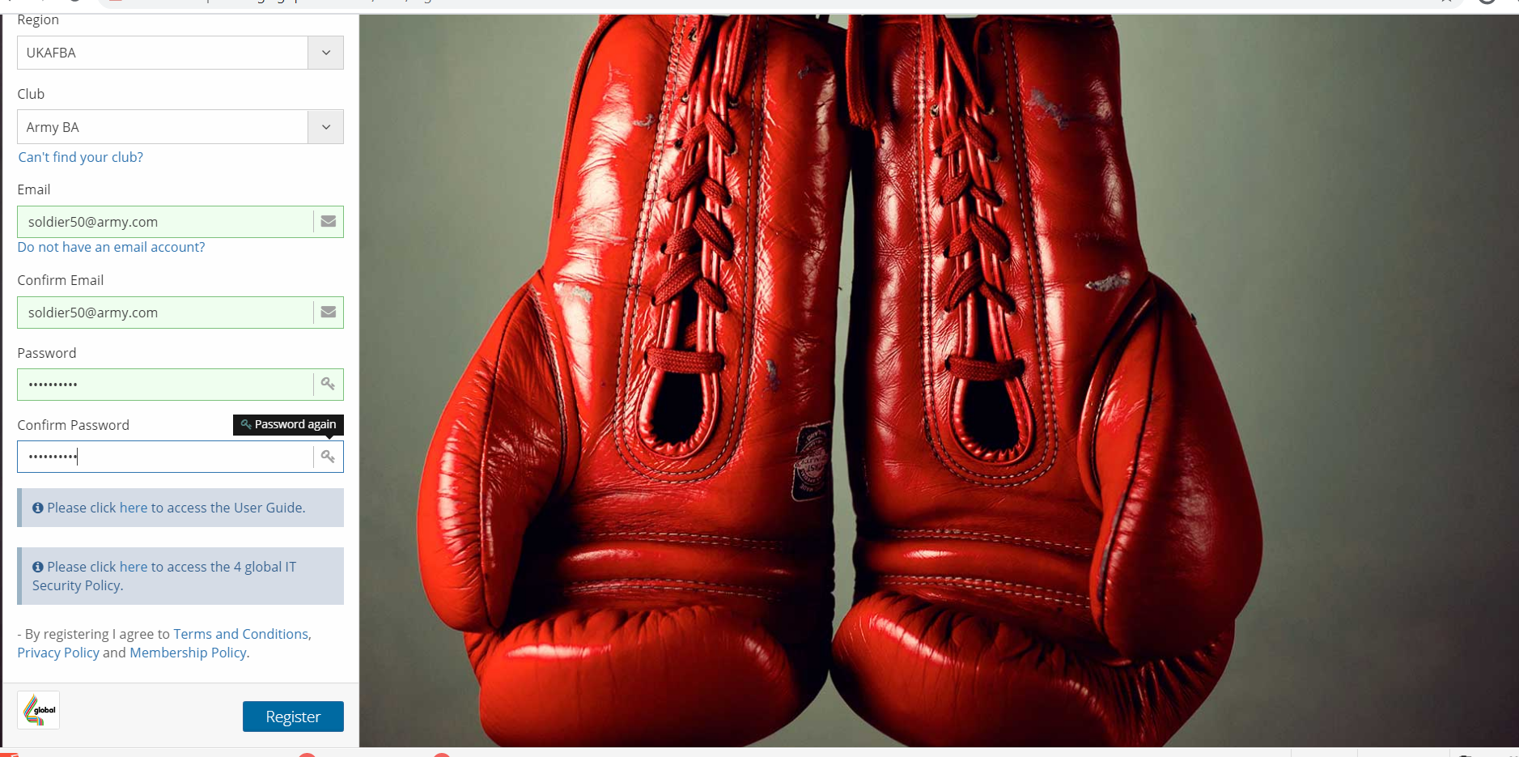

Once you have completed all the fields, click on the Blue register tab at the bottom.

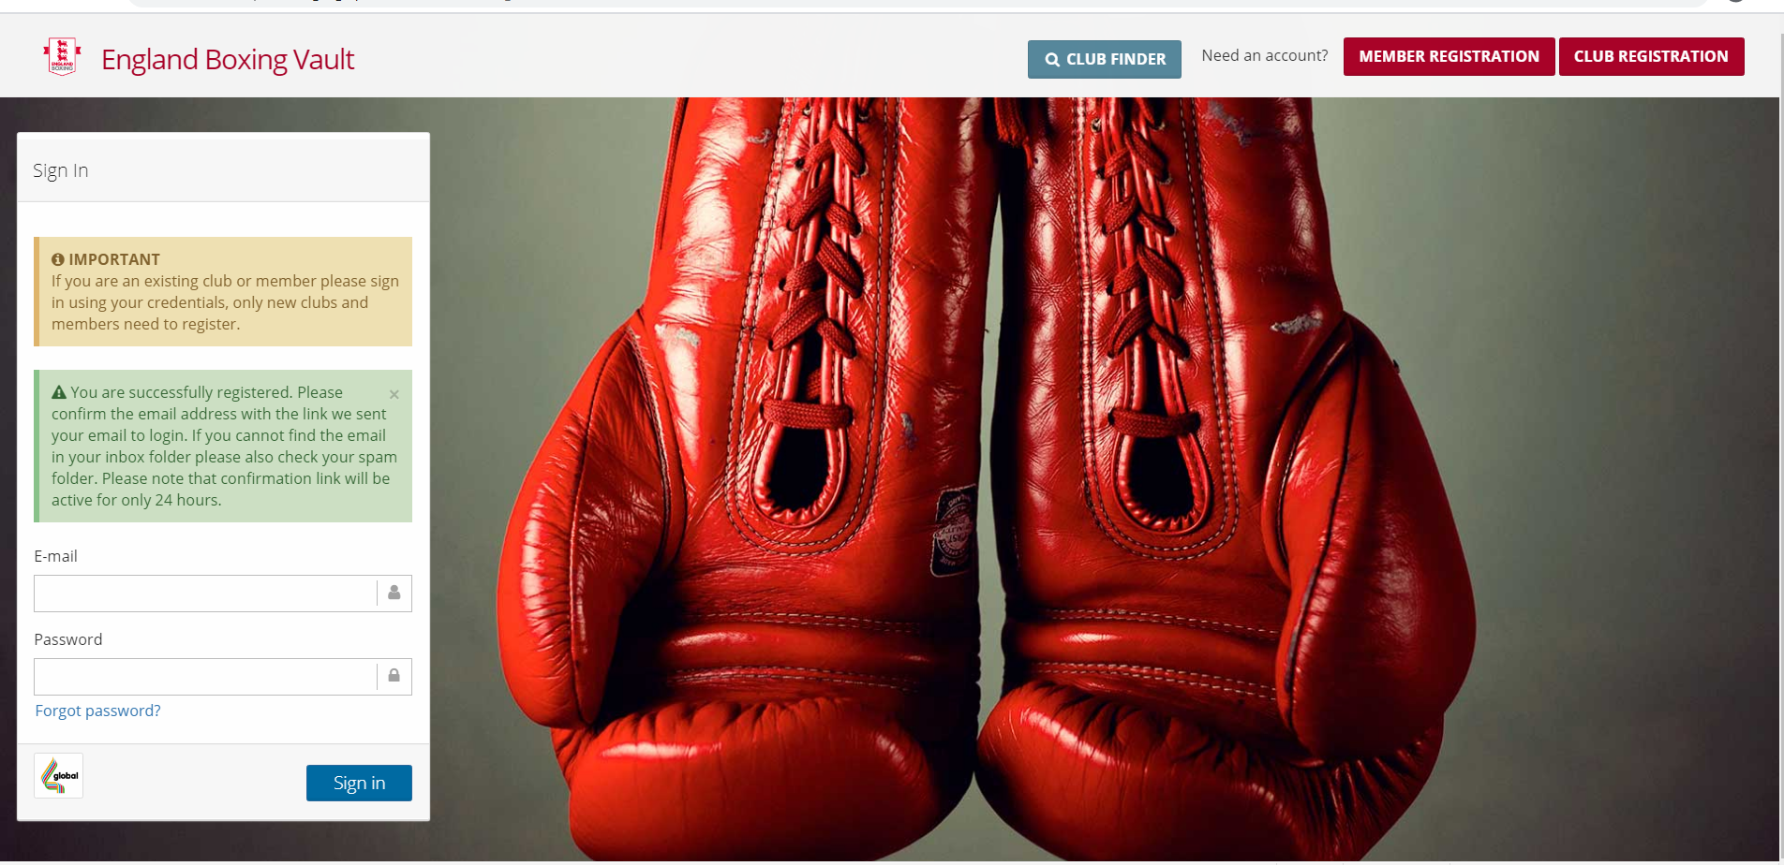

Once you have clicked the register tab it will automatically direct you to the window as shown above. You must verify your email address before you sign in to your Vault account. Please check your emails now so that you can verify your email address in order to continue your registration.

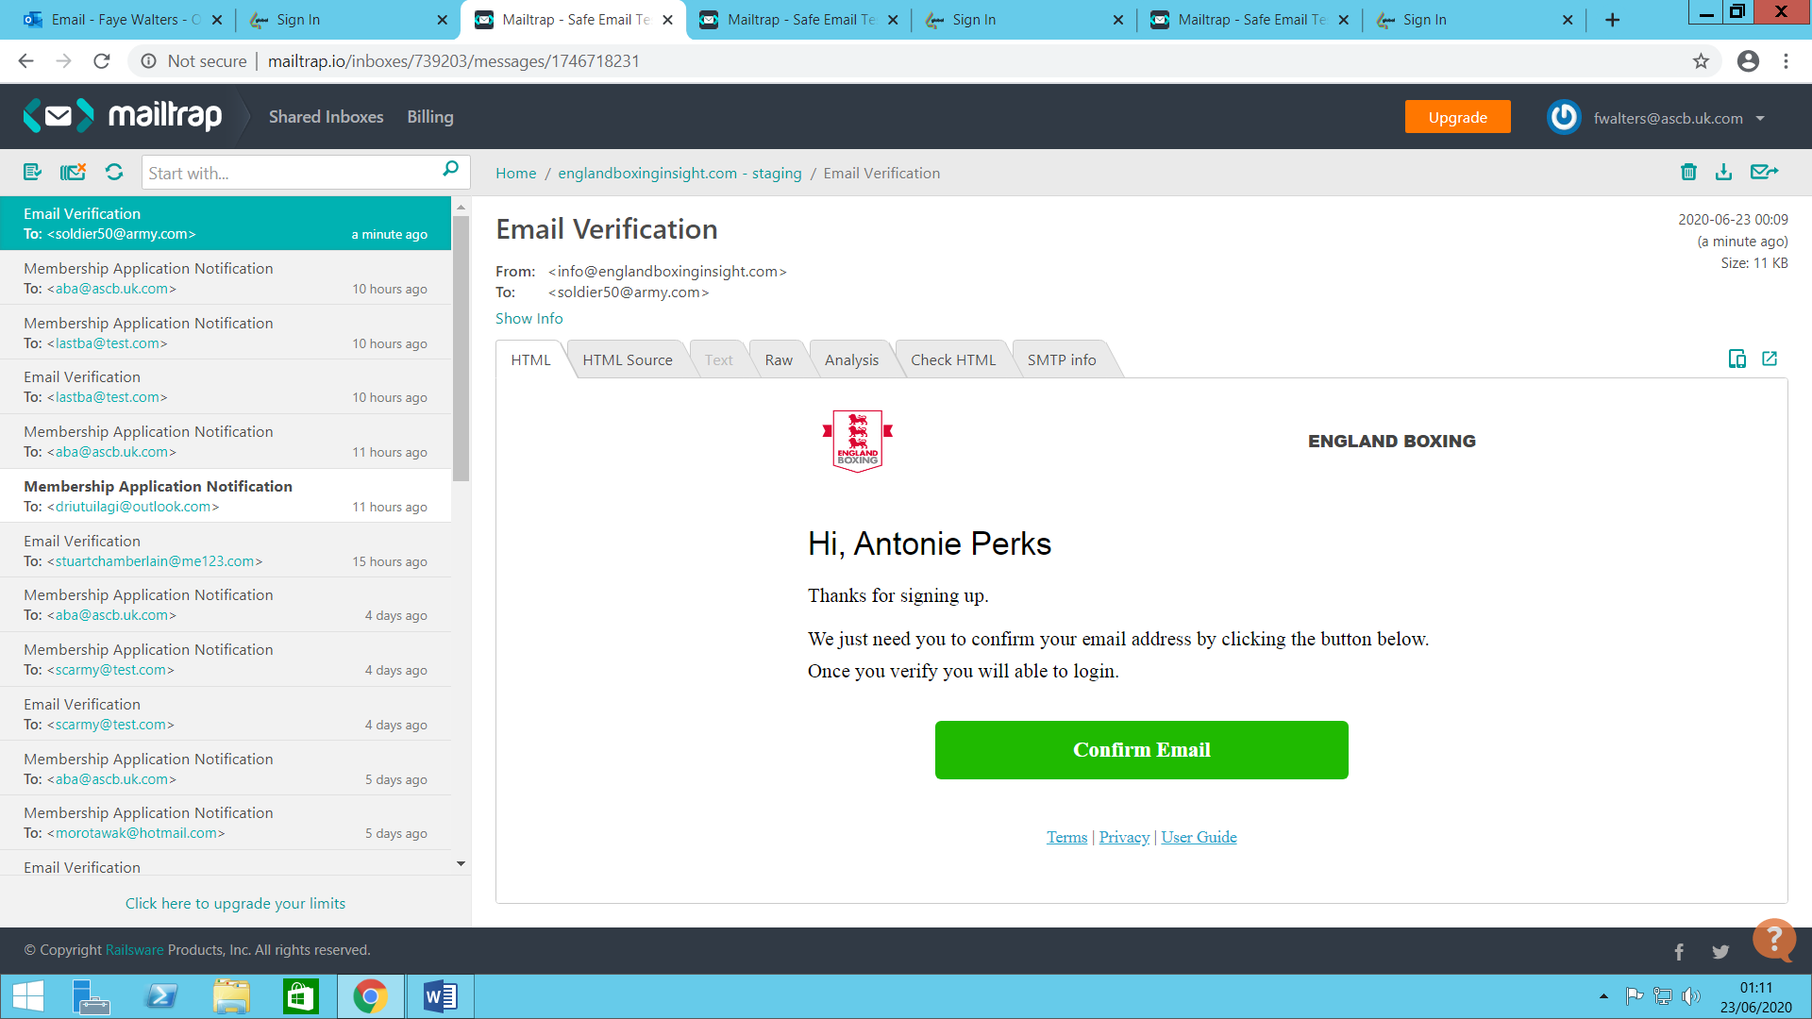

Please confirm you email via the Green Confirm email tab, it will automatically direct you to the England Boxing Vault

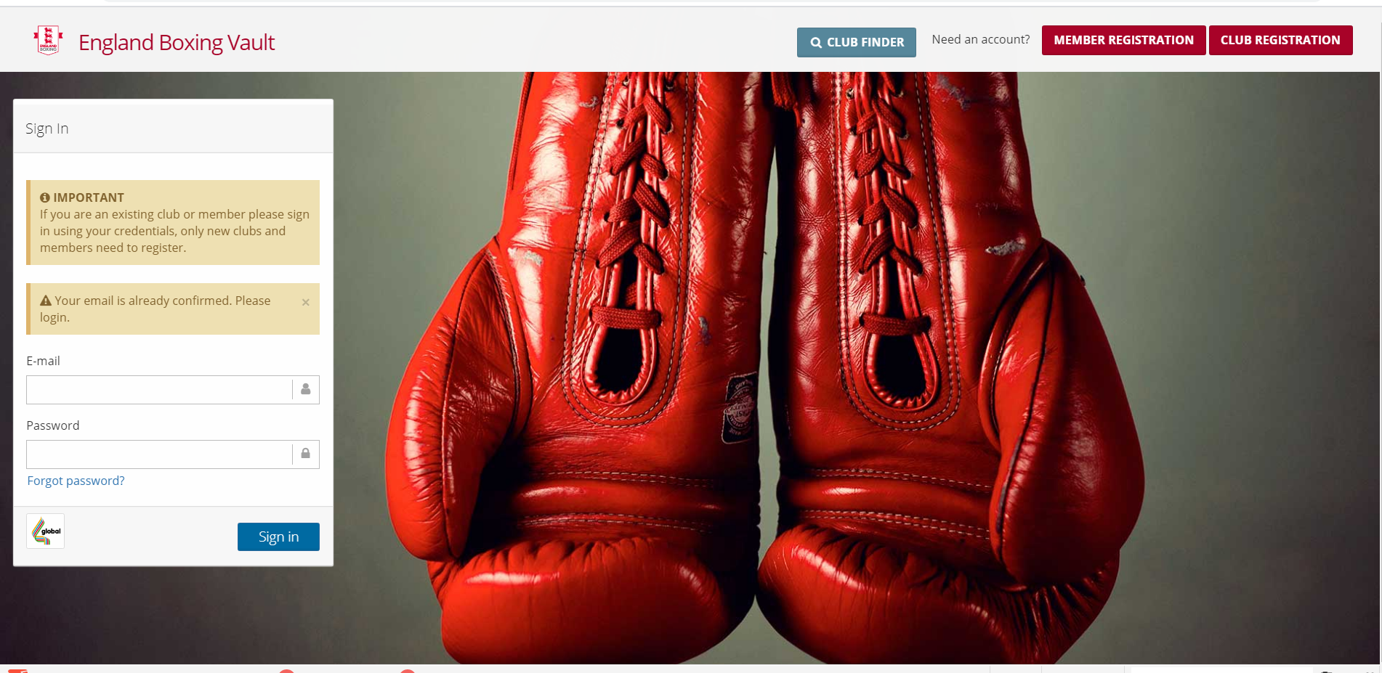

You will now need to sign in using the email and password you entered previously.

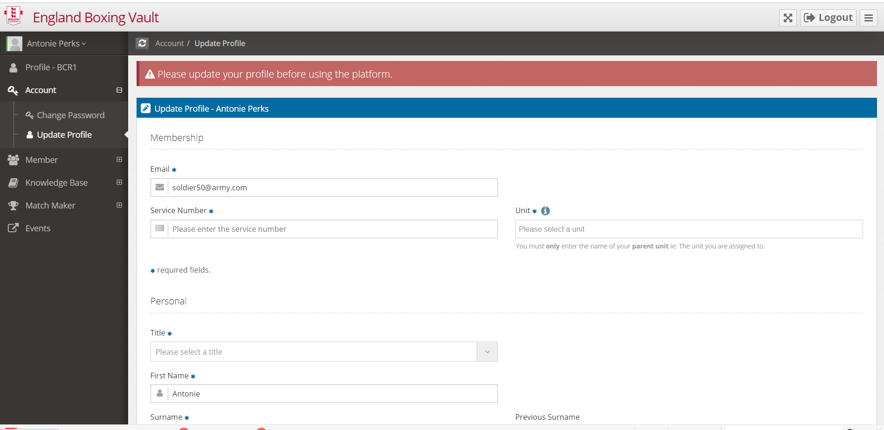

Once you have signed into your Vault account, you will need to enter the details as prompted on your profile.

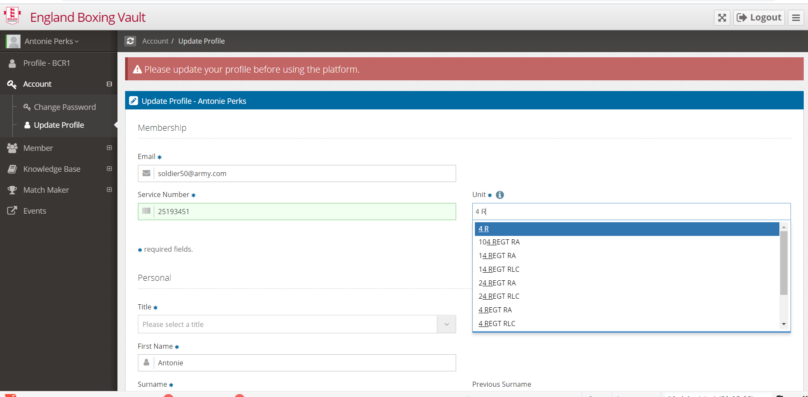

As you start typing your unit in the box it will automatically provide you with a list of units, if you cannot find yours just type it in, it will then add it to the list. Please remember that your unit is what you are assigned to.

If a question has a blue star next to it, you must enter the information, as it is a required field.

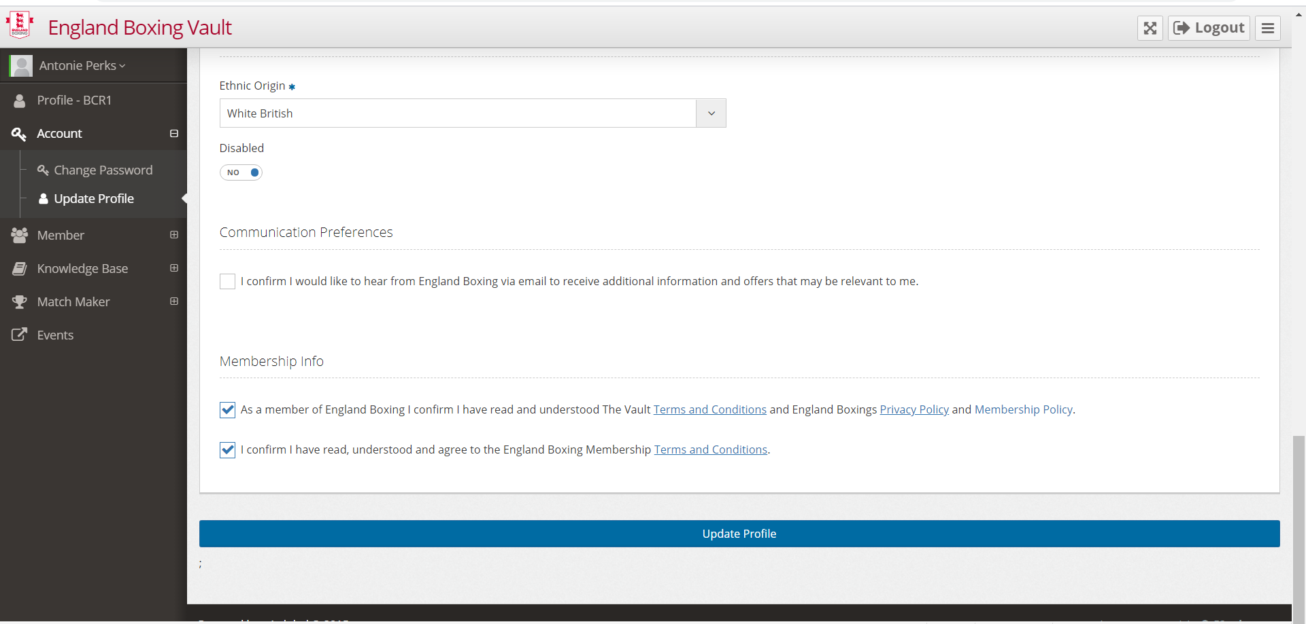

Once all fields are complete, tick the relevant boxes and the click the blue Update Profile button.

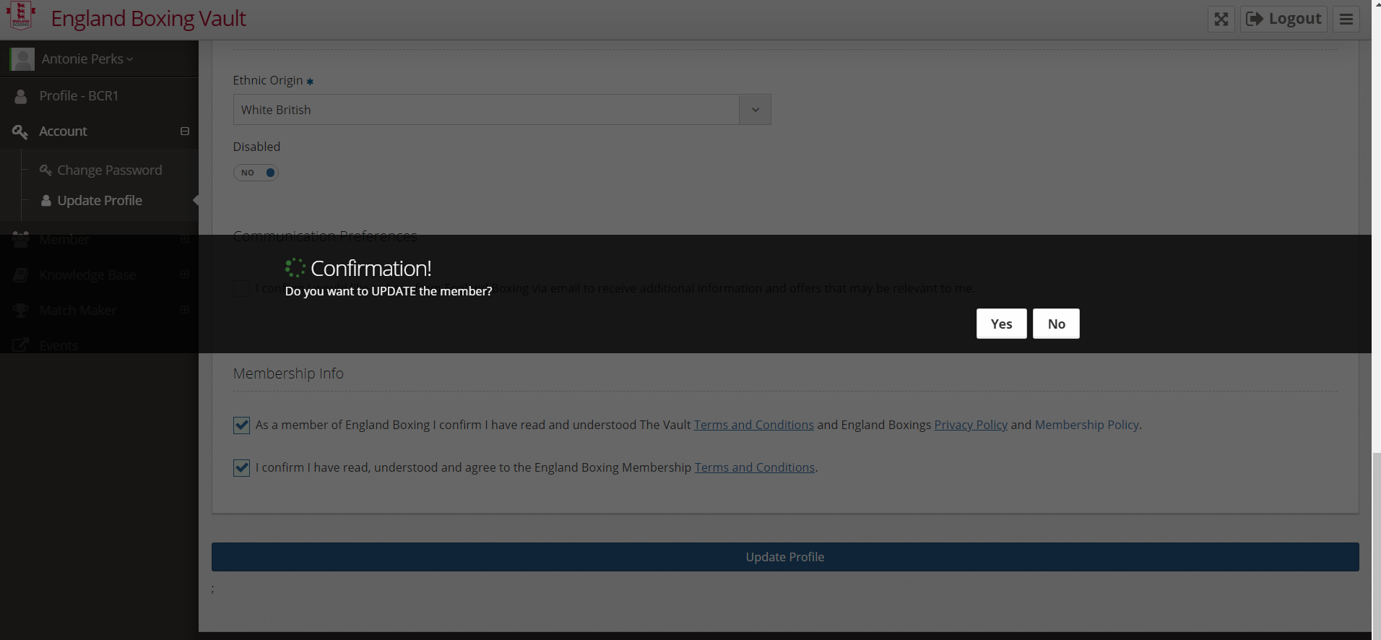

Click yes to proceed

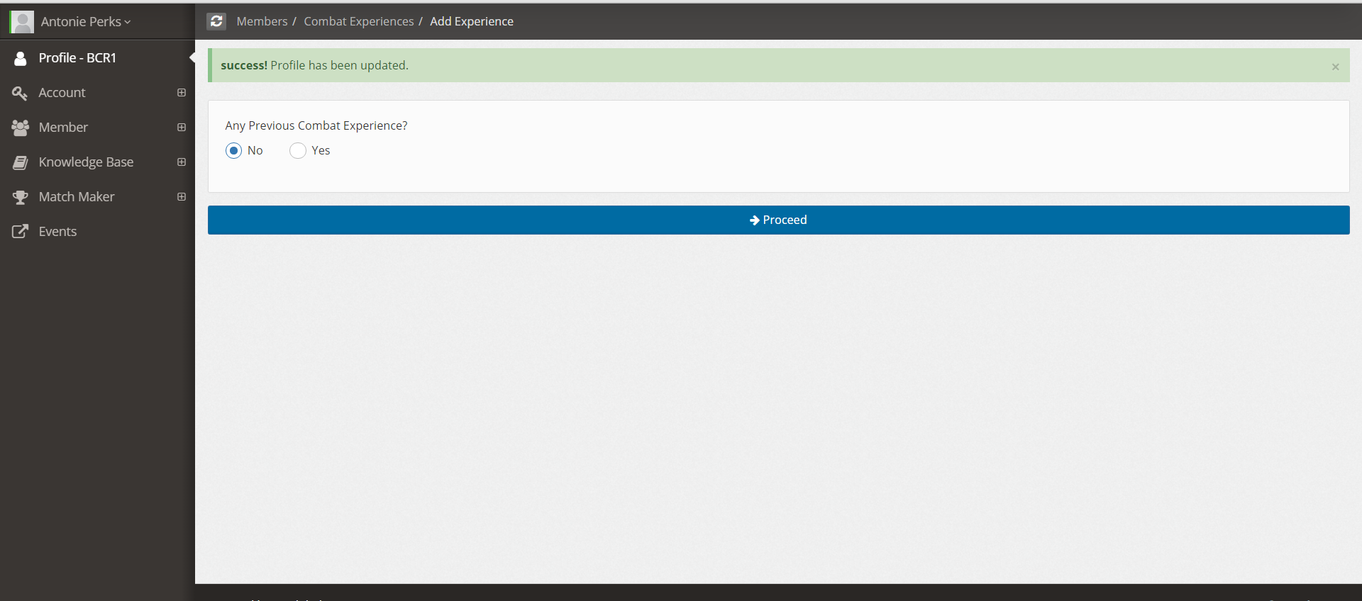

You will then be asked about any previous combat experience you may have had. If you have no experience click No and the blue Proceed button.

If you have had Previous Combat experience please Click Yes and enter the required fields

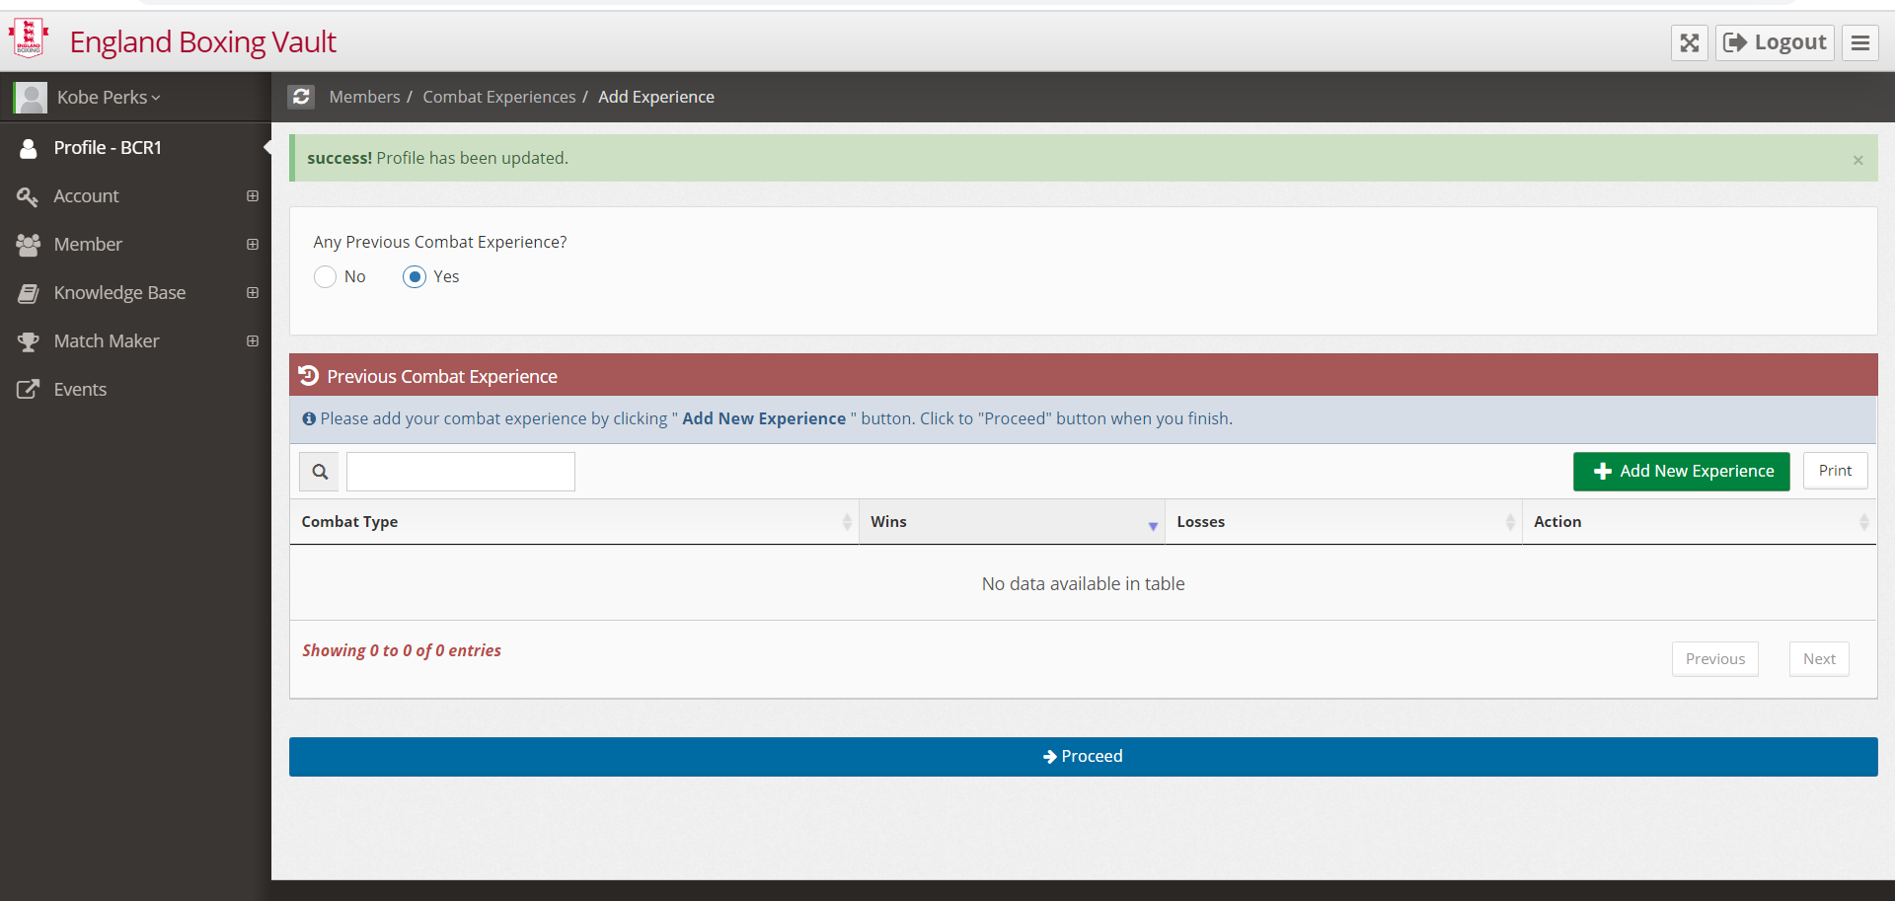

Click on the Green + Add New Experience tab

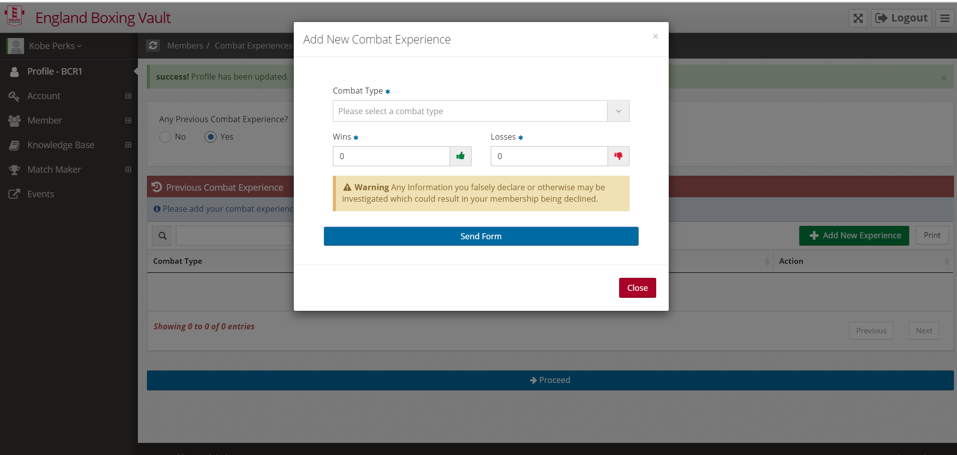

Enter the Combat type from the dropdown menu

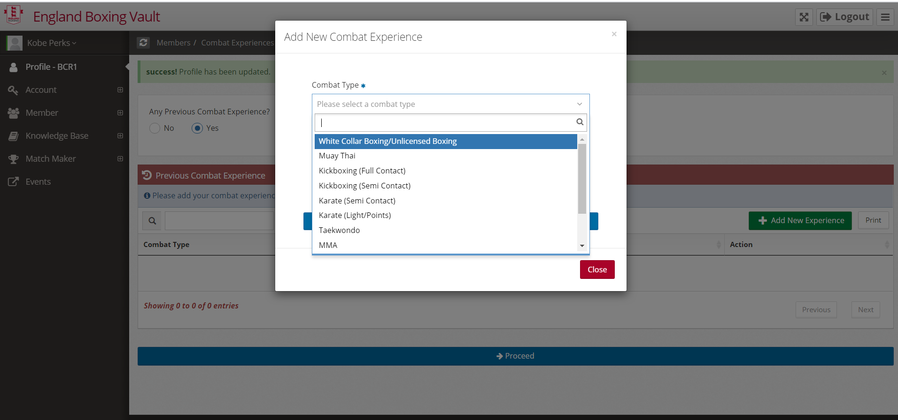

Once you have selected your combat Type, enter the number of wins and losses

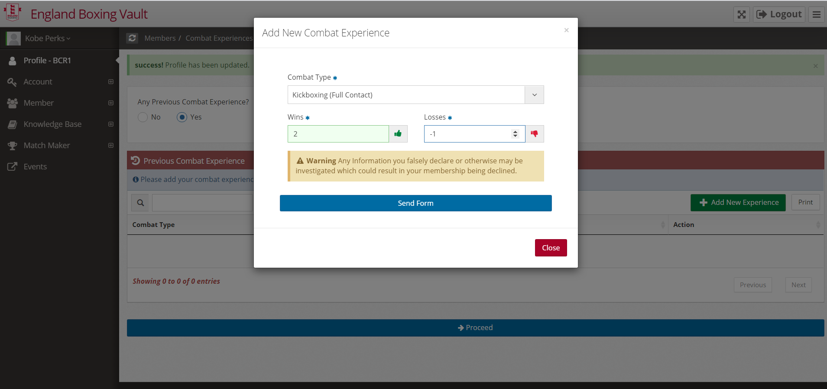

Then click the Blue send form tab

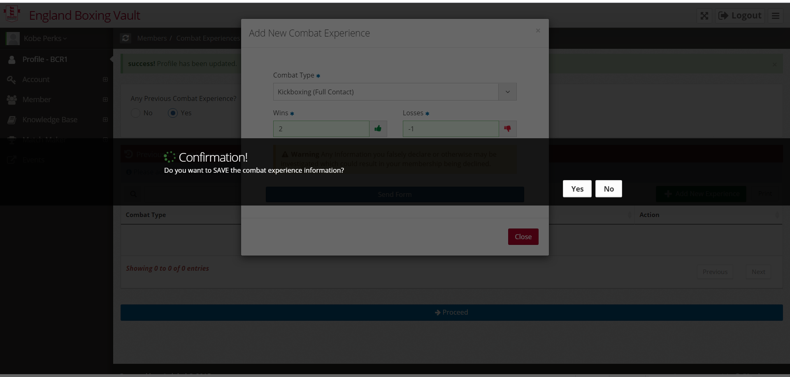

Then Yes to confirm

Your form will now be electronically sent to England Boxing for them to convert your previous Combat experience into Boxing bouts.

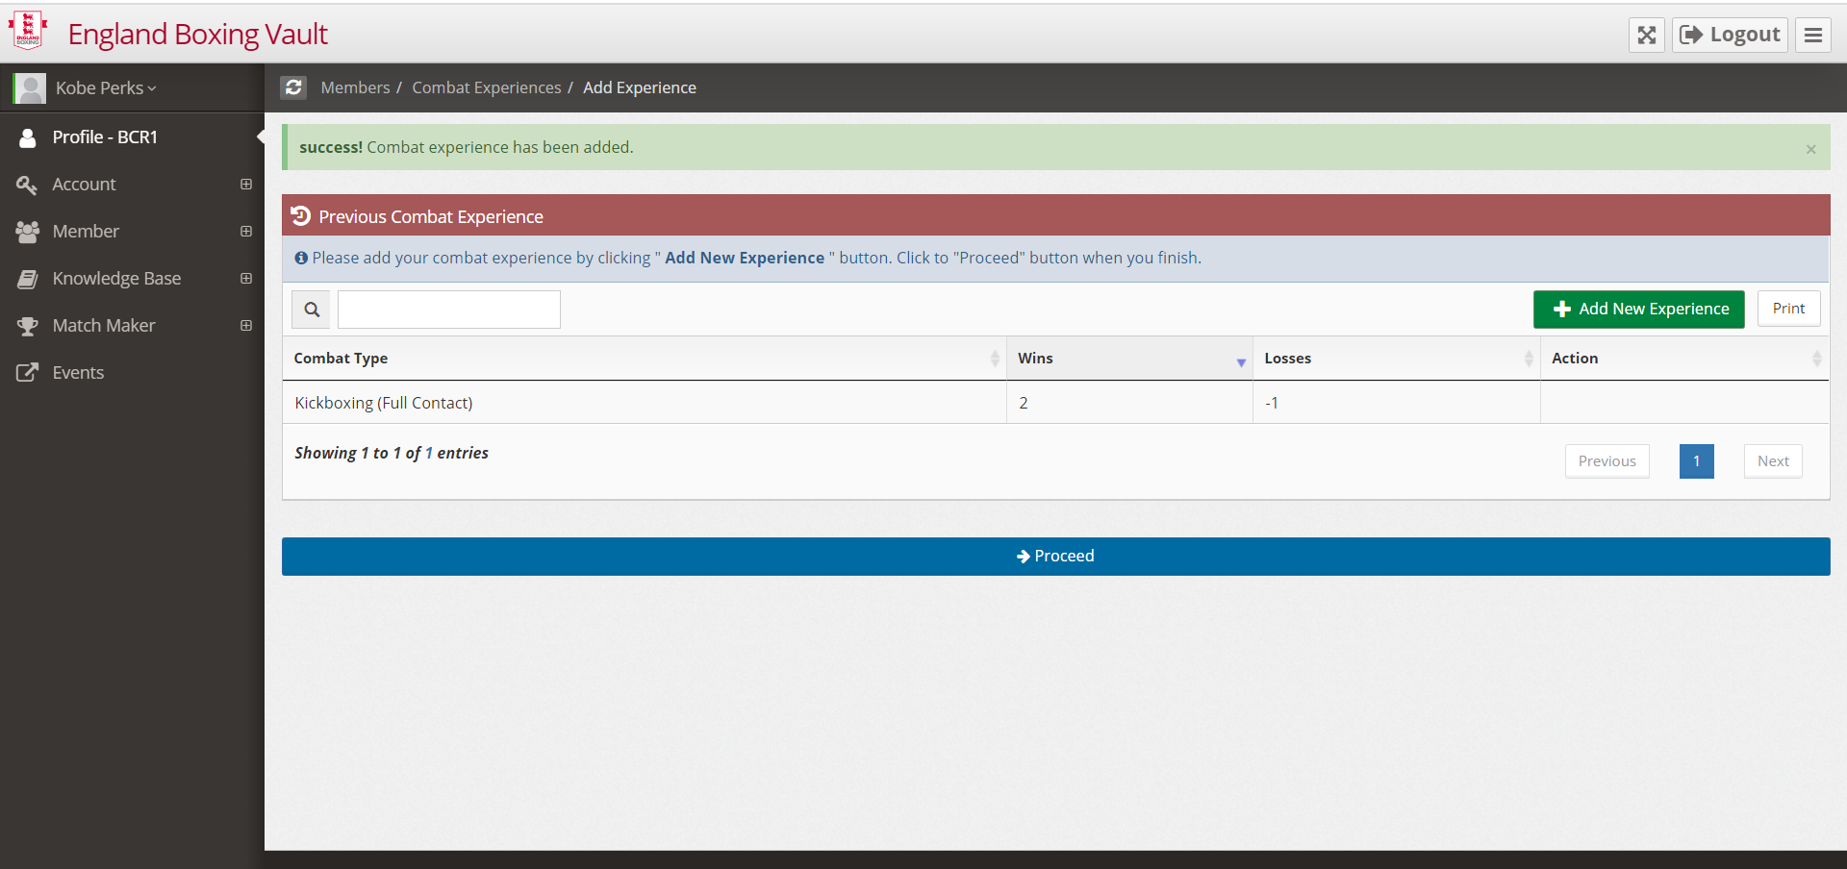

Click the Blue Proceed Tab

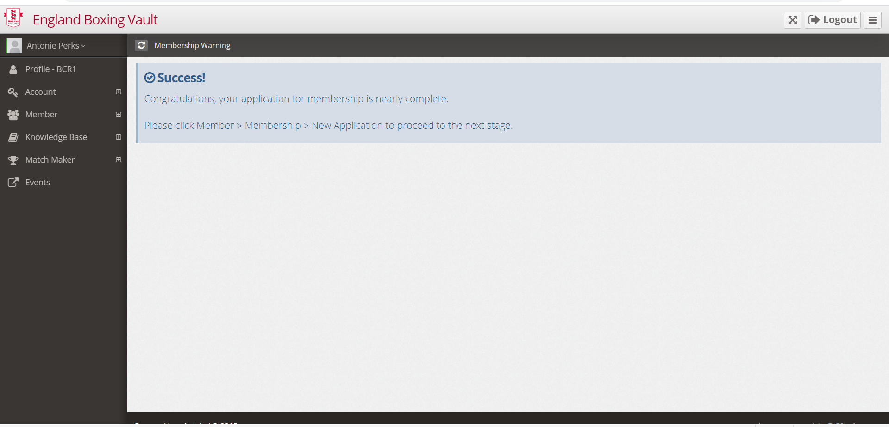

You must now click on the member tab on the left hand side of the page

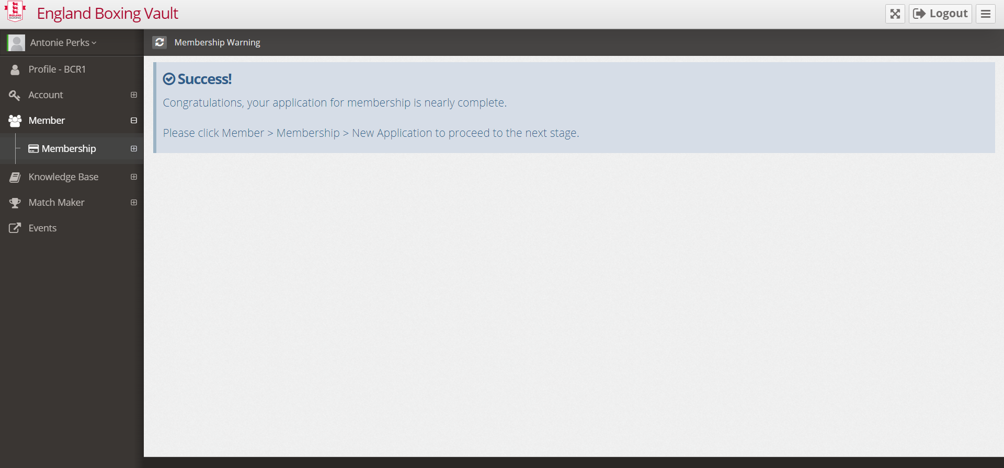

Then click on the membership tab

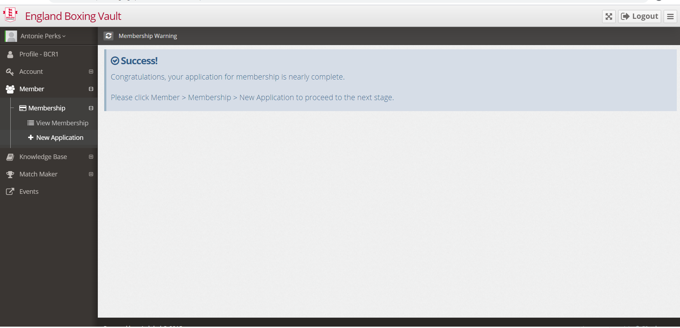

Then new application

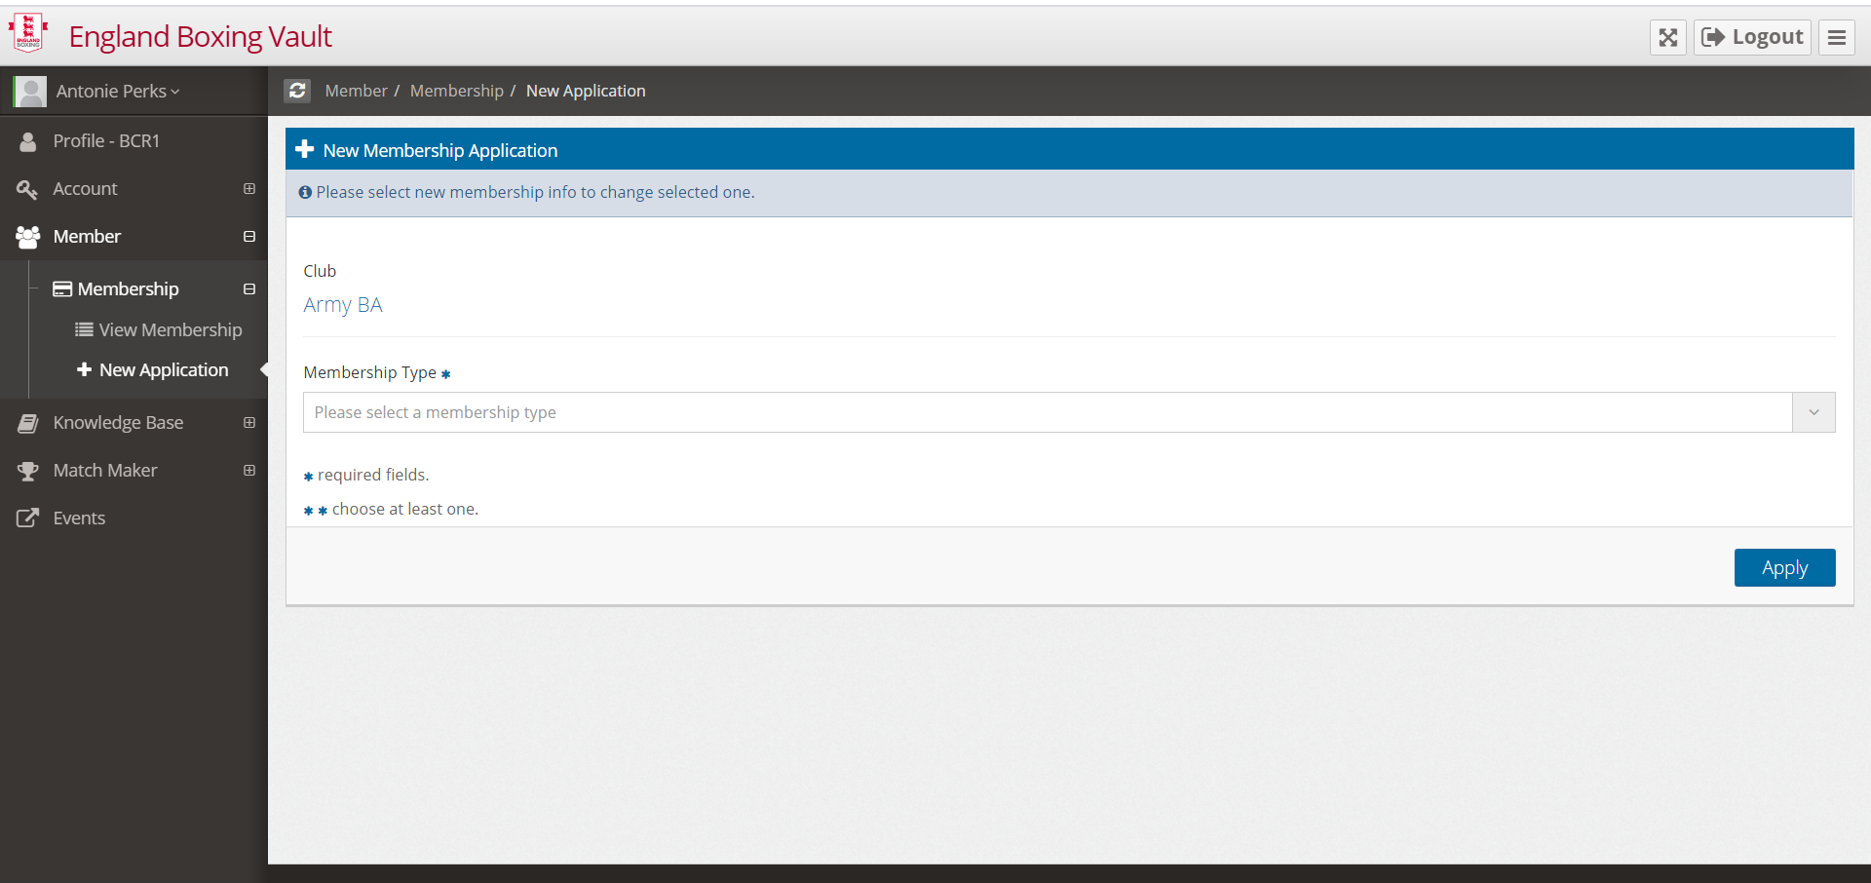

Please select the membership type that you require - for example Service only Coach

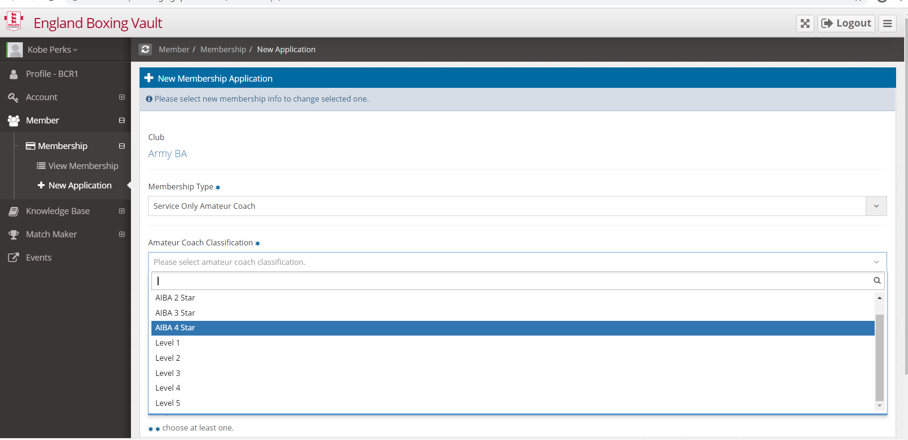

Select the Coach qualification you hold from the dropdown menu

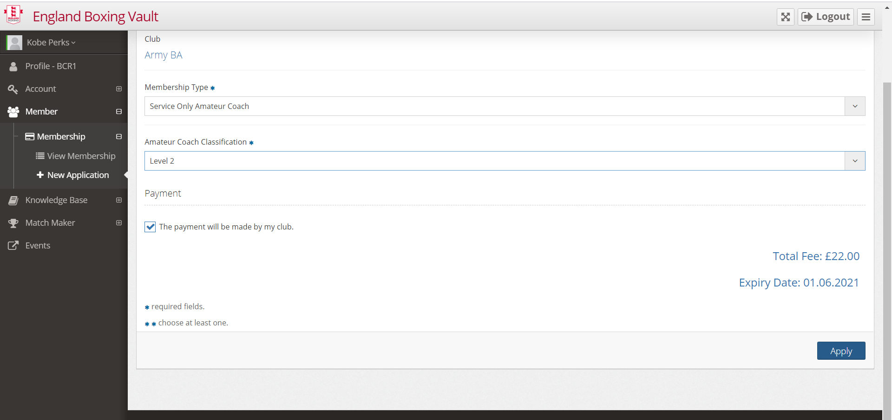

Then click the Blue Apply Tab – The cost for Service only coach is £5

The payment will be made by my club is automatically ticked and cannot be changed. This does not mean that the Army Boxing Association will pay for your membership – The £5 membership fee is to be sent to the Army Boxing Association.

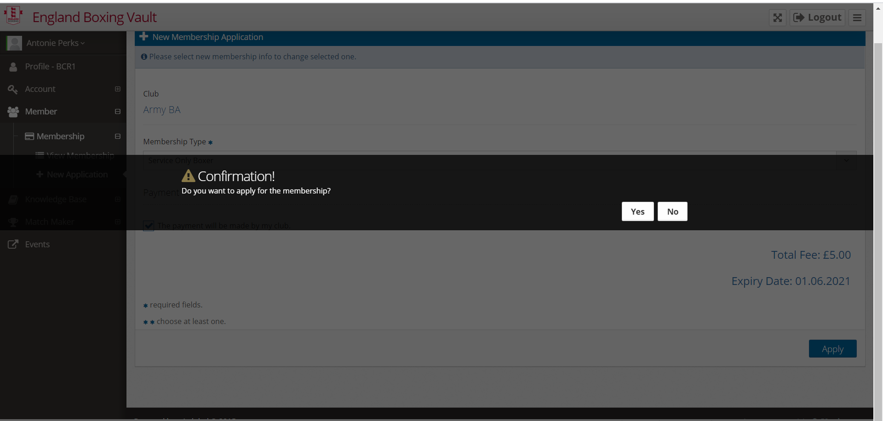

Click yes to confirm

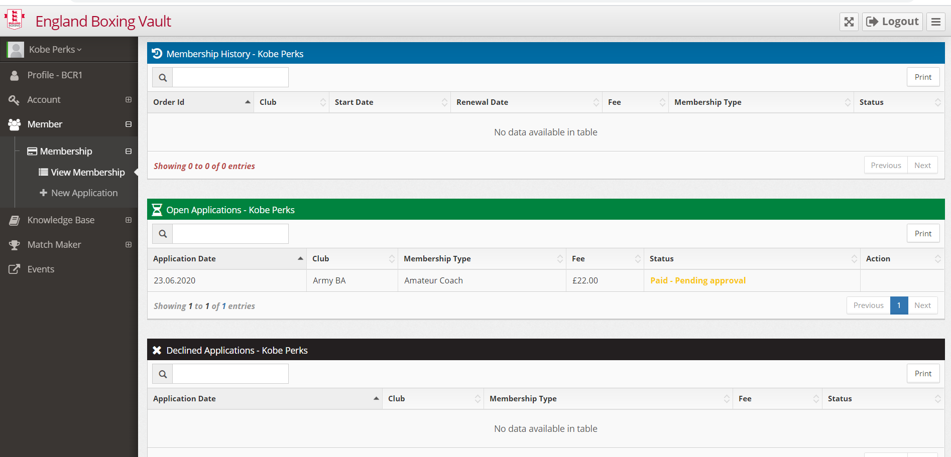

Your registration on the England Boxing Vault for Service only Coach Membership is now complete. You will now receive an email detailing your next step.

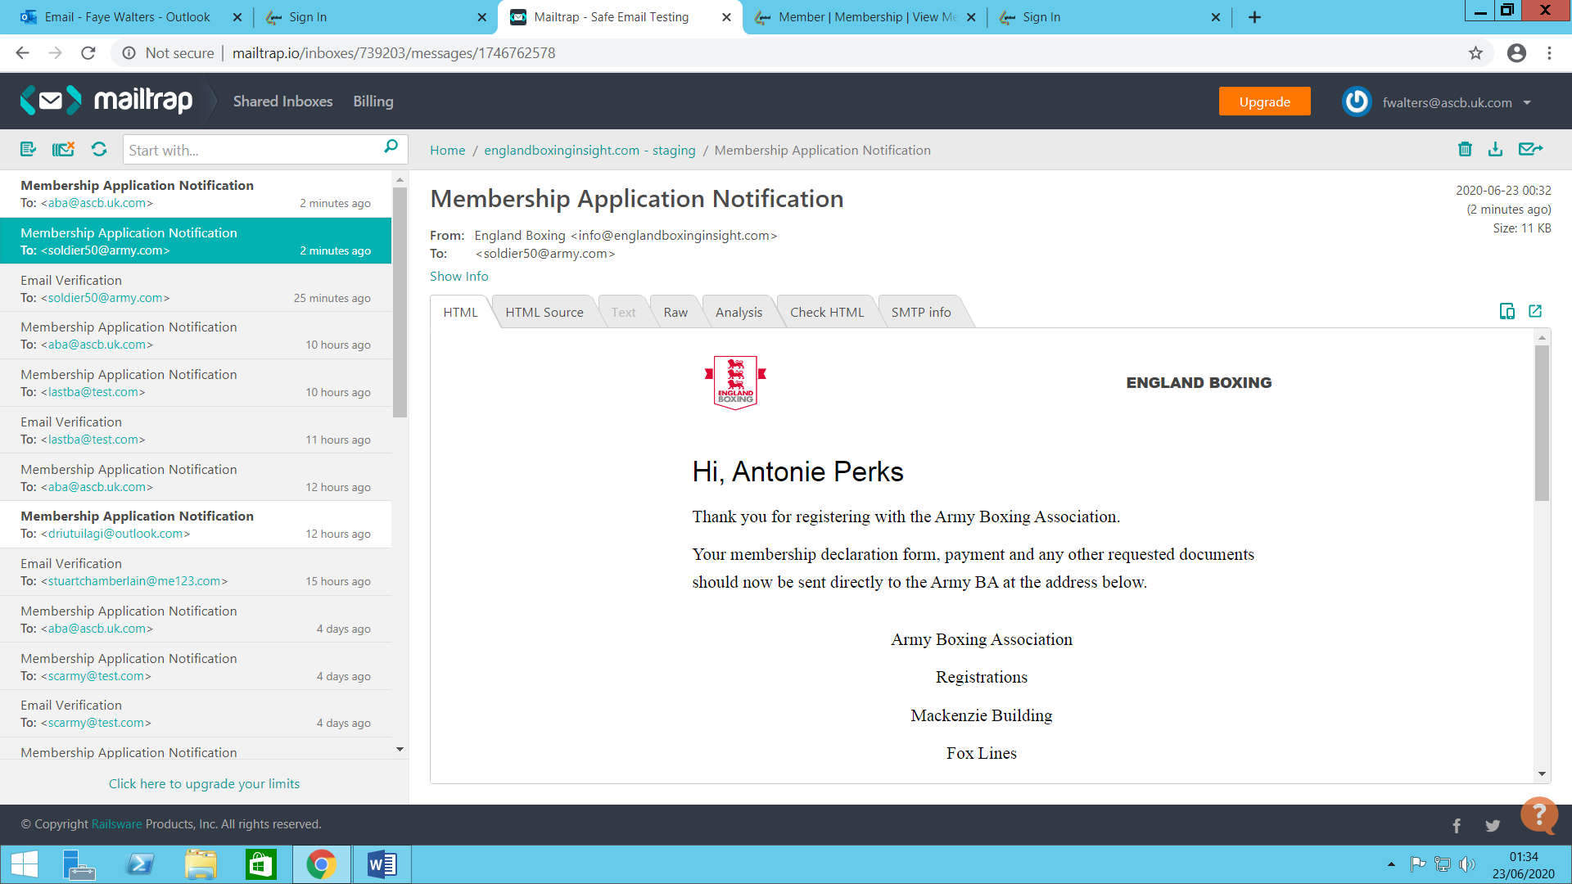

Your application will not be approved until all required documents have been received.

The declaration form can be downloaded from the Army Boxing Website
https://www.britisharmyboxing.com/information/downloads/

The registration fees for all Service Only membership types are £5.00 except for Service Only Officials where there are no membership costs. Information of required documentation to send to Army BA with their declaration form and fee can be found on the British Army Boxing Website.
Coaches will need to send declaration form, 1 x passport photo, Qualification certificate, MATT3 declaration, safeguarding certificate and £5 - existing members will also need to send in their coaches’ card.

