**Annex B to Section 8**

**UKAFBA Handbook 2020/21**

### Annex B - Paramedic Contacts for UK

**Northern Ireland**



Coastal Core Ltd

32E Ballyquin Rd

Limavady

BT49 93Y

Tel 028 7776 5469

[accounts@coastalcoretraining.co.uk](mailto:accounts@coastalcoretraining.co.uk)

**North**

**Cipher Medical Ltd**



Unit 5 Enterprise Court,

Queens Meadow Business Park

Hartlepool, Durham, TS25 2FE

Tel: 01429 872406 or 07979 527835

[info@ciphermedical.com](mailto:info@ciphermedical.com)

**Midlands (West)**

**Med Event UK**



5 Orpington Drive

Rowley’s Green

Coventry

CV6 4NJ

Tel: 02476 721813 or 07816 997493

[covmedevent@yahoo.co.uk](mailto:covmedevent@yahoo.co.uk)

**Midlands (East)**



**Viking Medical**

**Viking Medical Solutions**

Unit 5, Rutherford Center

Dunlop Road

Ipswich

IP2 0UG

Tel: 01473 557616 | 01473 557655

**South**

**OPS AMS**

**AZMA Medical LTD**



Kedron

Newham Road

Hook

HANTS,

RG27 9AE

Tel: 07767215186

[ady@amsservices.co.uk](mailto:ady@amsservices.co.uk)

**Acute Ambulance Support Services LTD**

7 Burners Lane,

Kiln Farm,



Milton Keynes

BUCKS

MK11 3HA

Tel: 0345 686 0301

01908 564 026

[info@aams-amb.co.uk](mailto:info@aams-amb.co.uk)

**London**

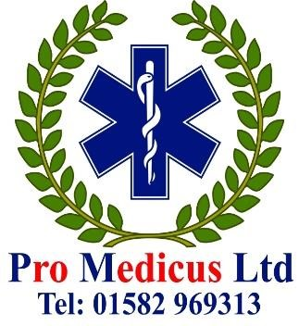

**Pro Medicus Ltd**

Thrales End Business Park

Thrales End Lane

Thrales End

Harpenden

AL5 3NS

Tel: (0) 800 802 1816

[office@promedicus-harpenden.co.uk](mailto:office@promedicus-harpenden.co.uk)